

Hockey Canada

High Performance 1  
Performance Planning:  
Additional Coaching Resource Material

Version 1.0





Table of Contents

Preparation for Program 1

Introduction 1

Preparation – A Part of the Leadership Profile 1

What is Ahead? 2

Planning A Competitive Program 3

Introduction 3

The Seasonal Plan: A Four-step Planning Process 5

Appendix A: Sample Documents, Planning a Competitive Program 12

Step 1: Describe the Coaching Culture 13

Step 2: Values, Vision and Goals – The Big Picture 17

Step 3: Organize a Seasonal Plan and Chart the Priorities 21

Step 4: Evaluate, Review and Refine – Staying on Course 23

Appendix B: Sample Templates, Planning a Competitive Program 1

**The Collection, Use, and Disclosure of Personal Information**

The Coaching Association of Canada collects your NCCP qualifications and personal information and shares it with all NCCP partners according to the privacy policy detailed at [www.coach.ca](http://www.coach.ca). By participating in the NCCP you are providing consent for your information to be gathered and shared as detailed in the privacy policy. If you have any questions or would like to abstain from participating in the NCCP please contact [coach@coach.ca](mailto:coach@coach.ca).

# Preparation for Program

## Introduction

Talent is important for a winning season, but as we consistently see in professional sport and in the Olympics, talent may not be enough. The real key to success is our ability to prepare our players for peak Program. The premise of this unit is that the best-prepared teams have the best chance of winning, and to achieve this, coaches today must plan and they must be highly organized. Two important areas that coaches can have a significant impact are planning the season for the competition and daily planning of activities.

This unit, *Preparation for Program*, will help the coach develop plans for a competitive Program and plans for effective training.

* It will justify the need for being well prepared and for detailed planning and organization.
* It will introduce a process, which similar to all plans, begins with the end goal.
* It will present strategies and tools for effectively achieving these goals.

## Preparation – A Part of the Leadership Profile

*“As a leader, you must understand this: You can never prepare too much.”*

- Rick Pitino (Louisville Cardinals)

Preparation is readiness. Getting the people, the environment and the activities ready for peak Program. It is a part of the leadership role of coaches of all successful leaders.

prepare - |priˈ pe(ə)r|

* make (someone) ready or able to do or deal with something
* make oneself ready to do or deal with something

To effectively prepare, we should answer the following:

***What must we be?*** – Are the players and staff ready for the expected or the unexpected?

***What must we have?*** – Is the environment (equipment, facilities or equipment) is ready?

***What must we do?*** – Are the actions ready, specific and meaningful (training, discipline, team work, systems)?

**The Leadership Profile**

In his book *Lead to Succeed*, Rick Pitino states, “Being prepared is a big part of being focused. Most people would be amazed at the amount of preparation we do before every game. We scout the other team. We break down film on them. We know their out-of-bound plays. We break down the individuals on the other team, to the point that we know their game inside out. Then we provide this information to our players. We go over it. We do everything we can to put us in a position to be able to win the game. This happens eighty-two games a year. Our competition does the same thing. It is no guarantee that we are going to win, understand, **but it gives us a chance** to win it…”

Pitino points out that preparation is what makes up focus, and focus is not a luxury. “It is not something you can turn off and on to your whim. Focus is a necessity, an essential part of the leadership profile.”

## What is Ahead?

Preparation in hockey includes many aspects such as scouting, team play, budgets and so on. This module Preparation for Program will focus solely on Program plans. This will include seasonal planning and practice planning. This section will introduce information, processes and tools to help coaches prepare the season for competition.

Coaches will learn strategies and use tools to:

* Get the key information to plan
* Organize and chart for the season
* Implement and apply in practices and games
* Evaluate, review and refine the plans

Is it vital that we prepare? There are many examples of highly successful coaches who believe this is true. Being the best prepared will give us the best chance to succeed.

# Planning A Competitive Program

## Introduction

*“Coaches, you must hear this loud and clear:*

*Organization and planning are blueprints to success!”*

- Dennis “Red” Gendron (University of Massachusetts)

All plans whether taking a vacation, raising a family, mapping our financial future or deciding on retirement follow a common planning process. They begin with the end. That is, they begin with a dream or desire. Of course, factors such as finances or time may limit the dreams, but at some time we map out the steps to achieving our aspirations. Along the way plans are modified to account for the changing environment or resources.

Building a seasonal hockey plan is no different. We start with our vision for the team, review our resources (our coaching culture) and then we map out the process of achieving our vision.

plan |plan|

* a detailed proposal for doing or achieving something
* (usu. plans) an intention or decision about what one is going to do

In hockey, the ‘seasonal plan’ is really a series of plans rather than a single plan. For example, we make decisions about scouting and recruiting, player evaluation, training, technical and tactical play, fitness and so on. Collectively, these map out our intentions for training and for competition.

This module on *Planning a Competitive Program* will identify effective coaching tools and strategies for identifying, organizing, managing and evaluating our seasonal goals. If done properly, our completed seasonal planning document will serve as a template for future planning.

### The Planning Process

In this module on *Planning a Competitive Program* coaches will explore ways to identify key components that affect competition, organize and chart priorities for each of these components for the season and evaluate, review and refine the plans. The concepts, activities and tools introduced will answer these questions:

|  |  |  |
| --- | --- | --- |
| **Seasonal Planning for a Competitive Program** | | |
| **Planning Step** | **Seasonal Plan** | **Tools and Strategies** |
| Where are we now? | Our Coaching Culture | Philosophy, team profile, staff profile, environment profile |
| Where do we want to be? | Our Values, Vision, Goals | Core values, vision statement, desired outcomes, general seasonal goals |
| What are the steps to our vision? | Our Organization and Seasonal Charts for the Objectives | Training elements, priorities, planning charts (dashboard, general macrocycle objectives, specific macrocycle objectives) |
| How will we know if our plans are working? | Our Evaluation Plans | Charts, statistics, rating scales, self-checks, questionnaires, interviews |

## The Seasonal Plan: A Four-step Planning Process

### Step 1 – Describe the Coaching Culture

**Process** – Reflection and Awareness: Collecting information

The tools in this step will help to answer the question, “Where are we now?”

An important step in the planning for the season is to reflect on the coaching situation. It is a background check for the job and, if detailed enough, it will reveal the strengths of the job and the limitations.

A formal and detailed assessment has several benefits.

* It helps keep things in perspective. It can confirm the validity of our vision and goals.
* It helps to create realistic competitive and training expectations.
* It is vital for effective decision-making and conflict resolution.
* It is necessary for effective communications with players, staff, parents and our associations.
* It will dictate how we evaluate. It is important for focus – keeping everyone on the same page.

Every coaching situation creates different challenges that will affect training and Program outcomes. Before we make too many plans, we must take stock of the team, the personal and the coaching environment. Knowing the strengths and limitations of our human and material resources will help us set effective, practical objectives. The hockey season is a long one and writing a detailed coaching culture helps our focus throughout the season. Being focused is what preparation is all about.

**Key Tools:**

1. Coaching Philosophy and Values
2. Team Profile
3. Staffing
4. Coaching Environment

### Step 2 - Prepare the Team Values, Vision and Goals – The Big Picture

**Process** – *Keeping the end in sight – Keeping the future in front*

The tools in this step will help to answer the question, “Where do we want to be?”

All plans begin with a vision of what can be. They are our dreams and we dream big. We dream of winning gold medals not just making the playoffs. Visions are based on core values. Values are qualities that we hold dear. Often, they form the foundation of our beliefs, attitudes and behaviors. They are statements of our principles, or standards, of behavior. They are our judgments as to what will be important to our team this year.

The following tools will help us communicate a picture of what our team will be at the end of the season.

**Key Tools:**

1. Writing team values
2. Stating a team vision
3. Stating the desired outcomes
4. Identifying general seasonal goals

### Step 3 - Organize a Seasonal Plan and Chart the Priorities

**Process** – Organizing and charting information through training elements, priority objectives and seasonal calendars

The tools in this step will help to answer the question, “How will we achieve our vision?”

**Key Tools:**

1. Training Elements
2. Objectives (Prioritized)
3. Seasonal Planning Charts

* The Dashboard

**Identify Training Elements**

What factors will affect the Program of our team this year? We might feel that our players need to develop quickness or be in top physical condition. Perhaps we feel that being disciplined, playing the systems or team bonding will be critical for success. Our first task when organizing our information is to determine the areas or categories that will be developed. These are called *training elements*.

Most team sports train common elements like physiology, technical/tactical skills, team play, psychology and so on. Here is an example of training elements for hockey keeping in mind that each sport will have some unique factors.

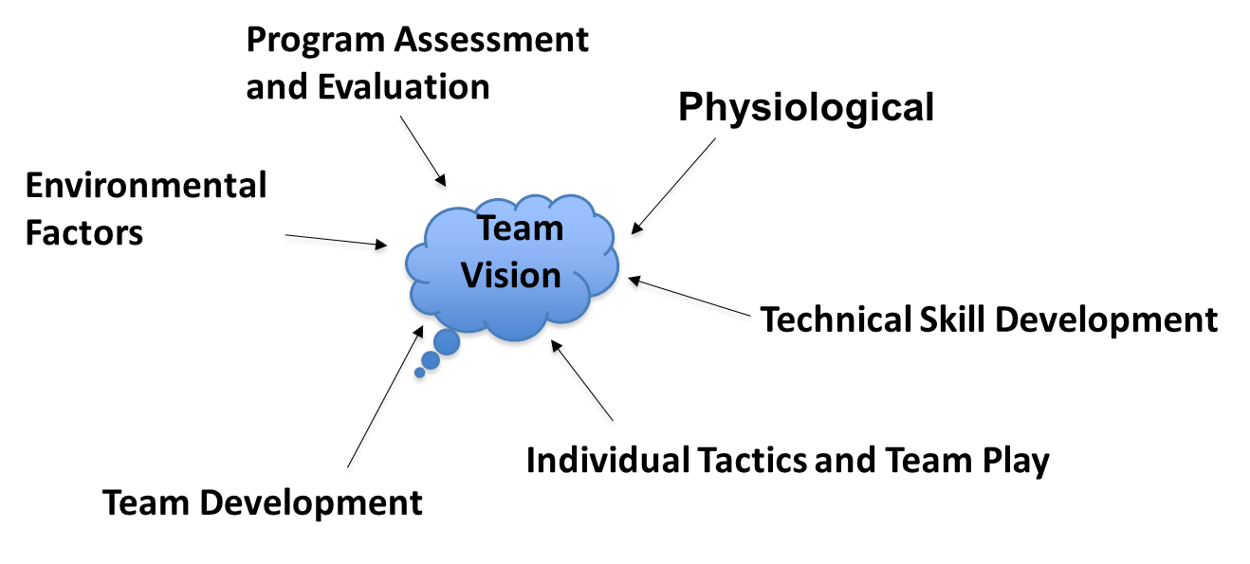

**Examples of Training Elements for Hockey**

**Identifying Priorities**

The next task when organizing information for our seasonal plan is to identify the components to develop each training element. For example, we might feel that flexibility, anaerobic energy systems, strength or quickness should be developed in the physiological element. These objectives will vary for the different age, skill and competitive levels. Therefore, coaches must have a thorough understanding of the coaching culture if we are to make effective decisions.

It is valuable to list all the components that we think are important, but we must realize that we cannot do everything. We must *prioritize the list*. These priorities, the components that will have the most impact on our successful Program, become the focus of our training.

**The Seasonal Planning Charts**

Coaches use different tools to track and record their day-to-day activities and training goals. One of the more familiar methods is to use calendars. Calendars are both cyclic and repetitive. For example, we may practice some specific technical skill every week or each month. This illustrates the repetitive nature of calendars. But we sometimes build skills upon skill over a period of time. Revisiting and refining training is the cyclic nature of our planning.

It would be valuable to see all the months of our calendar at a glance rather than over a series of monthly calendars. The following tools will do exactly that. We will design a seasonal planning chart that will help us display our seasonal plans and activities at a glance. It will more effectively help us track the repetitiveness and cyclic nature of our training.

***A Planning Dashboard***

We begin by building a yearly timeline. We call this graphic representation a *Dashboard*.

Here is an example:

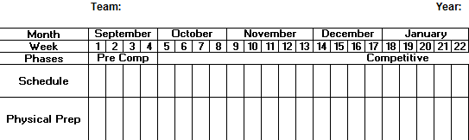

**How does it work?**

The dashboard brings planning for the season to front. Like a movie marquee, it highlights what is to follow. An effective Dashboard will contain the following components.

A timeline – This is our calendar at a glance. It combines all of the monthly calendars into a single timeline. If you prefer, you can further break these into weeks or days. For short-term competition planning, your calendar would extend from your appointment to the wrap-up.

Phases – These are the months that make up the preparatory phase, the competitive phase or the transition phase.

***Preparatory phase*** – the general preparation and basic skills period. This may include try-outs, training camp, basic skill development, dryland training, team meetings, parent meetings and meetings regarding philosophy, plans and nutrition. This would include pre-season exhibition and team building activities.

***Competitive Phase(s)*** – On-ice and off-ice training and tactical work to develop Program. This would include regular season games, tournaments and playoffs. Sometimes we will have two or more parts to the competitive season especially if we have a longer Christmas break or an extended period prior to playoffs. In tournament play we would probably only have one phase.

***Transition Phase*** – This is the period from the end of the season to the beginning of the next. It can be viewed as active rest but should include strength training, general fitness maintenance and participation in other sports.

Macrocycles – This term describes the training units within each phase. It improves the cyclic nature of the monthly calendars and it more effectively tracks the cyclic nature of training. The duration could be from 4 to 6 weeks per training cycle. Each macrocycle will have a unique theme in the development of Program. For example, the first macrocycle of the season might be for player evaluation and selection, training camp and basic skills and tactics. General conditioning may also be important here.

Activities Bar – This bar will identify the key activities throughout the season. For example, it may identify the exhibition games, team meetings, ice sessions, off-ice sessions, playoffs or tournaments. It is important to identify the ***peak period***. This will be a target for peak Program where all of the training elements need to be at their best. A period preceding this peak will be a taper period where we maintain intensity, but decrease volume of the training.

**Summary** – Using the Dashboard concept, we now have our season, training periods, activities and peak period in front of us. We can then use this tool to organize general objectives and specific actions.

### Step 4 – Evaluate, Review and Refine

**Process** – To assess our success, review our plans and make necessary revisions.

The tools in this step will help to answer the question, “How will we know if our plans are working?”

**Benefits of an Effective Evaluation Plan**

Planning helps coaches keep the future in front of them. A good plan will identify what we want to achieve and it will map out a clear route to get there. But plans are exactly that, plans! They are our intentions or our decisions, but they are not the competitive reality any more than a map is the actual journey, or a blueprint is the physical building. As such, plans needs to be regularly updated.

Benchmarks, or checkpoints, can indicate how well we are advancing to our goals. These may be empirical benchmarks such as goals against, scoring chances or finished checks where we can set desired standards, or levels. However, there are some more subjective benchmarks that require observation, rating, ranking or checklist rather than statistics. Examples of this would be defensive zone coverage, winning the 1 vs. 1 battles or player’s work ethic.

Sometimes just having evidence may be a sufficient indication that we are achieving a goal. For example, when measuring a tactic like a net drive, it really doesn’t matter how many times we observe it as long as it exists and it contributes to our overall offensive pressure at the net.

Some of the benchmarks might be planning benchmarks like deciding when to introduce a new forecheck or power play rather than Program based. Others might measure individual actions such as recording blocked shots, plus-minus ratings or goaltender save percentage average. These could also be converted into team benchmarks by compiling shots against or scoring chances for the team as a whole.

Again, the important to the success of an evaluation plan lies in the planning and organization.

An effective Evaluation Plan will provide the following benefits:

* It will check our progress
* It will clarify our thinking – criteria for objectives
* It will clarify communications
* It will determine future planning

| **Strategies for evaluation** | |
| --- | --- |
| **Sample Strategy** | **Example:** |
| ***Checklists***  List the priorities and check off if we have them or not. | Objective Strong Poor Needs Work  Skating Quickness √  Puck protection √  Give and go √ |
| ***Observation***  Subjective assessment – is the action evident. | Objective Evident Not Evident  Finished checks √  Blocked shots √ |
| ***Observation Ratings Scale***  Rate qualities on a scale 1, 2 or 3. These assessments can be accumulated for the season. | Objective Rate 1, 2 or 3  Work ethic _____  Shares puck _____  Defensive responsible _____ |
| ***Using Statistics***  Be clear about the purpose of the statistic and our resources | Objectives:  Face offs – Face off percentages per zone  Defensive play – goals against  Offensive play - scoring chances  Goaltending efficiency – percent save average |
| ***Rankings***  Collect data to rank players, actions or needs. The ranking would be based on established criteria. | Objectives:  Player evaluation and selection – depth chart, ghost roster  Face-off personal – from the face off statistics  Penalty killers – from penalty killing goals against or plus/minus |
| ***Interviewing*** | Examples:  What are your strengths? What do you feel you need to improve? How would you rate your defensive play today? |
| ***Questionnaires***  Written answers, checklists, one-on-one, drop box | Examples:  What are your goals for this practice?  How will you know if you are successful? |
| ***Self-Evaluation*** | Rate yourself on a scale of 1 to 3 for your Program today:  ___ Work ethic  ___ Defensive play  ___ Offensive play  ___ As a team player |

# Appendix A: Sample Documents, Planning a Competitive Program

## Step 1: Describe the Coaching Culture

**The Coaching Culture**

**Coaching Philosophy:**

**Team Profile:**

Include information about the following:

A description of the club, branch or organization

A description of the athletes including number of athletes, age level, competitive level, past Program, player characteristics

A description of the Competitive Level including caliber of competition, characteristics and past history.

Planning needs – what will be required. Needs.

**Staffing:**

Staff Structure: A description of the human resources associated with the team.

Staff expertise: strengths, weaknesses and experience. SWOT, Venn Diagram

Staff roles and responsibilities

Past history

Needs

A Self Analysis through SWOT

Strengths – Weaknesses – Opportunities - Threats

1. My Current Strengths?

These will be things that I bring to the team and will use to help the team be successful.

1. My Weaknesses?

These will be things that I will need to overcome and would like to improve on.

1. The Opportunities, I Believe Exist For Me To Gain Through My Participation.

These are things that I must try to take advantage of to improve myself and enhance my effectiveness in my role.

1. The Threats That Might Exist, and That Could Derail Or Hurt My Success & That Of The Team.

These are things that I / we must be on guard against.

**Staff Biography, Roles and Responsibilities**

**Head Coach –**

***Biography:***

* Resides in Red Deer
* Played goal
* Coached for 27 years at most levels of hockey
* Extensive junior and college coaching experience
* NCCP HP 2 Certification
* Level V certified official
* Licensed mechanic ticket
* Out of province and write off repair

ticket

*Job Description:*

The head coach is appointed by the president to be responsible for all of the team and personnel matters. This includes on ice and off ice conduct at the arena.

The head coach is responsible to the board through the president and he is responsible for all players and staff.

*General Responsibilities:*

* Coordinating communications between the board, the staff and the team
* Final say in all team matters
* Delegating responsibilities
* Plan on-ice and off-ice activities in consultation with the assistant
* Coordinating scouting, player evaluation and player selection plans.
* Coordinating training and tryout camps.
* Communicating to the president the progress of the program
* Implementing and controlling pre-game and post-game preparation and communication with the team
* Designing necessary practice plans and technical handouts in consultation with assistant
* Coaching the team
* Establishing roles and responsibilities of the staff and monitoring their effectiveness
* Establishing rules, guidelines and codes of conduct for the team and coordinating the supervision of discipline of the athletes.

|  |  |  |  |
| --- | --- | --- | --- |
| **Specific** | **For the Athletes** | **For the Practices** | **For the Games** |
| * Attend all team functions * Meet with staff weekly * Organization * Conduct athlete interviews * Communication plan * Develop ice plans * Build a team playbook | * Set discipline and consequences implement the plans * Schedule meetings * Team building * Player profiles | * Build ice plans * Build drills and run * Pre ice and post ice practices | * Manage Bench * Game plans * Pre/post-game communications * Lineups * Do game sheet * Discipline and consequences * Plus minus stats * Scouting * Work forwards and goaltenders |

**Example of a Staff Strength Venn Diagram:**



**Evaluation, review and refine:**

Writing down your coaching situation is an important first step. However, even the best plans fail. The following activity will help coaches state realistic visions and goals. Coaches should list on a continuum what would be **ideal** in terms of players, Program, staff and goals, and what would be **realistic.**

|  |  |
| --- | --- |
| **What is ideal for this team?** | **What is more likely real for this team?** |
| Quick, fast skating  Physical  Play the team game  Coachable players | Small and quick, but not really fast  Too small to be a physical, more dependent on moving the puck and team play.  Need to overload in corners, in small areas  High Program players, some will have their own agenda – try to keep communications open |

## Step 2: Values, Vision and Goals – The Big Picture

**What are Values?**

***“All things that we believe to be important and worthy***

***of our time, energy, commitment and resources”***

**Individual Values**

***“The actions and beliefs by which we live our lives”***

***\* respect, honesty, integrity, fairness***

**Team Values**

***“The things that we stand for”***

***“Should be shared by all on the Team”***

***“Should guide the day to day behaviors of the team”***

***“Real or Perceived they are the culture of the team”***

**Customer Values**

***“The end condition that a customer considers worthy***

***of his or her approval”***

***“Covers everything from a tangible piece of merchandise***

***to a pure experience”***

***“The value is in the result perceived by the customer”***

**VALUES . . . What is important to you!**

Respect Honesty Integrity Trust

Courage Self-Discipline Fairness/Fair Play Creativity

Commitment Dedication Equality Cooperation

Reliability Enthusiasm Consistency Fun

Responsibility Excellence Reliability Discretion

Pride Tolerance Courtesy Patience

Inclusive Ethical Safety Development

Innovative Flexibility Optimism Generosity

Team Work Loyalty Openness

Empathy For Others Community Involvement

Recognition / Appreciation Kindness & Caring

Stewardship – taking responsibility for the future health of the company

**VALUES . . . What Are Yours & Mine?**

**Value Clarification:** Complete the first two tasks by yourself.

1. From the above list, identify (circle) ten values that you believe are important for you to be successful in your life, your work & in your relationships.
2. Then identify the values, you believe are important to be demonstrated by CHAM and its employees.
3. In small groups, share & discuss your values answers for CHAM. Prioritize your list and discuss as a group until you agree on the ten most important values.
4. In your group, define the values as you might “see” them being demonstrated in your workplace.

**VALUES**

Virtually every team (organization) has invested some time (perhaps significant time) determining their key values. Here are the values of one very large and famous company:

* Communication
* Integrity
* Respect
* Excellence

Do these represent your own organization's values? If yes, you should be concerned!

These are the corporate values of Enron as stated in the company's 2000 annual report…..Oops.

Enron simply went through the motions of creating their organizational values. Obviously, these values didn't mean much to the leadership team there! The organizational values Enron listed were out of sync and in direct contrast with the personal values held by the management team. The Enron leadership deceived themselves thinking a hollow set of organizational values would somehow save them from their own self-destructive personal values.

**LEADERSHIP FACT**

Before you (your team) can create a set of values for the organization you must FIRST identify / clarify your own personal values. Why? - Your personal values are the building blocks that allow you to see the big picture and move forward with clarity.

Trying to identify the team's values without first identifying your own is like trying to drive a car with sunglasses covered in mud. It's a huge distraction to say the least! Why work on your personal values? Because leaders go FIRST. You must become clear on YOUR values before you can help your team do their work. There is no other way

If you're on a team and it's time to identify the team values and you haven't first done the work yourself then you risk ending up like Enron. What would you expect driving with sunglasses covered in mud?

When you understand what it means to clarify and then reorient your life around your core values you'll get what Patrick Lencioni (bestselling author of "The Five Dysfunctions of a Team") means when he says: "When properly practiced, values inflict pain". Pain? Yes, pain. Here's what Lencioni says about real, meaningful and honest team values:

* "They make some employees feel like outcasts. They limit an organization's strategic and operational freedom and constrain the behavior of its people. They leave executives open to heavy criticism for even minor violations."
* In other words, operating from a solid and authentic set of values will set you (and your organization) apart and help you clearly define who you are and what you stand for.
* And the ONLY way you'll ever be able to have the strength to establish values like these is when you've done the work on a PERSONAL level FIRST.
* It's the Law of Correspondence: As within, so without.

**Benefits of Being Values-based (personally and organizationally)**

1. Goal setting is easier and goals can be reached more quickly.

2. Your life purpose/vision comes to you more clearly.

3. Fewer distractions occur; life is simple, but rich.

Source: Teamworks Canada, Inc.

**Values, Vision and Goals Worksheet**

**Example of Core Team Values for Hockey**

*Open and clear communications:* (sincere, genuine, frank, straight forward, integral)

*Trust:* (reliance, confidence, belief, faith)

*Accountability:* (ownership, being responsible, being in the here and now, working for solutions rather than looking for fault, solve problems rather than judge.)

**Example of a Team Vision:**

**Team Vision:** “Teamwork for Excellence – athletes, leaders and citizens”

Our team will be a hard-working group of skilled athletes who are committed to the team vision, the team goals and to each other. We will be coachable, adaptable and flexible, and we will be willing to accept roles and execute them to the best of our ability. We will play ‘in your face’ style of hockey built on a foundation of passion and intelligence. Because of our passion, we will be prepared to pay the price for success and we will be able to bounce back quickly from adversity. We will be known for our self-discipline, desire and determination. In the community we will be seen as leaders and role models.

**Planning Goals:**

***Examples of Expected Outcomes;***

Ultimately: Win the tournament

Primary: Make the medal round

Secondary: Enjoy the experience; make friends, growth as individuals

***Examples of Goals:***

|  |  |  |
| --- | --- | --- |
| What must we **BE** to succeed? | What must **DO** to succeed? | What must we **HAVE** to succeed? |
| * Skilled * Character People * Committed * Passionate | * Work hard * Execute under pressure * Improve skills * Commit to the team * Prepare   + Physical   + Mental   + Technical/Tactical   + Team | * A plan * Trust and support * Team atmosphere * Leadership * Organization |

## Step 3: Organize a Seasonal Plan and Chart the Priorities

**Training Elements and Priorities**

Team Unity

* Common Vision
* Goals
* Identity
* Motivation
* Leadership

Psychological Factors

* Mental Skills
* Emotional Skills
* Communications

Team Play Factors

* Offensive strategies
* Defensive strategies
* Transitions
* Special team play
* Goaltending

Technical/Tactical

Factors

* Offense
* Defence
* Transition
* Special Play
* Goaltending

Physiological Factors

* General Fitness
* Training
* Health

Factors Concerning the Athlete

* Skill Level
* Character
* Passion

Environmental Factors

* Competitive Plan
* Travel
* Outside influences
* Office duties

Team  
Vision

**Developing Action Plans – Strategies for development**

**Physical Factors Action Plan**

**Mission:** To develop the general fitness level of the athletes

**Teams:** Staff, trainer, partners (fitness center, field house, contracted trainer)

**Factors:** General condition, general fitness, flexibility

**Tools:** Weight room, equipment, field house, gym, individual training schedule

|  |  |  |
| --- | --- | --- |
| **Physical Factors** | | |
| ***Priority*** | ***Goals and Actions*** | ***Comments*** |
| Conditioning  Flexibility  General Fitness | ***To condition the athletes through high tempo, intense practices***  Actions:   * Build high tempo practices through flow drills * Minimize inactive time * Teach off ice where possible   ***To convince athletes to develop off ice training habits.***  Actions:   * Provide sample off ice training programs * Reinforce with interviews * Monitor fitness level with field tests and logs   ***To develop a daily stretching routine***  Actions:   * Give the players a sample stretching program * Monitor players prior to ice activities * Use training logs   **To build general fitness in the athletes**  Actions:   * Educate the players on what good fitness is and the lifelong benefits * Educate athletes on substance abuse * Help athletes monitor their fitness |  |

## Step 4: Evaluate, Review and Refine – Staying on Course

|  |  |  |
| --- | --- | --- |
| **Evaluation Plan** | | |
| **Team: Date:** | | |
| **Mission:** | | |
| **Processes** | **Evaluation Plans** | **Measures** |
| Vision, Values, Goals  The Influencing factors  The Objectives of each Action Plan  Our general and specific macrocycle objectives  Our planning process |  |  |

***Plan a Practice Evaluation Form***

***(Planning a Competitive Program)***

|  |  |  |  |  |  |  |  |  |  |  |  |  |  |
| --- | --- | --- | --- | --- | --- | --- | --- | --- | --- | --- | --- | --- | --- |
| **Coach Name** | |  | |  | **CC number:** |  |  |  |  |  |  |  |  |
| Surname | | First |  | | | | | | | | |
| ***IDENTIFIED*** | | | ***EVIDENCE OF ACHIEVMENT*** | | | | | | | | | | |
| **Criterion: Identify logistics and appropriate background information for practice** | | | | | | | | | | | | | |
|  | Practice plan identifies a goal or a series of key elements that will be addressed in the practice. | | | | | | | | | | | | |
|  | Practice plan identifies basic information including, date, time, location, number of athletes, level of athletes. | | | | | | | | | | | | |
|  | Practice plan indicates basic logistical needs (i.e. facilities and equipment) to match the overall goal. | | | | | | | | | | | | |
|  | Practice plan has a clearly identified goal that is consistent with NCCP growth and development principles. | | | | | | | | | | | | |
|  | Practice plan is organized into main segments that include an introduction, warm-up, main part, cool-down and a conclusion. | | | | | | | | | | | | |
|  | Duration of the practice and each practice segment are identified on a timeline. | | | | | | | | | | | | |
|  | Plan includes a list of key factors or teaching points that relate to the overall goal. | | | | | | | | | | | | |
| **Criterion: Identify appropriate activities in each part of the practice** | | | | | | | | | | | | | |
|  | Integrate activity modifications that increase athlete cognitive effort and provide appropriate challenges from a technical, tactical, physical, or decision-making point of view | | | | | | | | | | | | |
|  | Create activities for the specific needs of the participant or team based on analysis of Program in competition | | | | | | | | | | | | |
|  | Ensure the clearly identified goal(s) that is/are consistent with the following: Hockey Canada LTPD; growth and development principles; competitive level of the athletes; time of the Yearly Training Plan | | | | | | | | | | | | |
|  | Ensure the duration of the practice and each practice segment is consistent with NCCP growth and development principles and the accepted guidelines for the development of athletic abilities | | | | | | | | | | | | |
|  | Ensure, where appropriate, planned activities reflect awareness of and control for potential risk factors (environmental, mechanical, human) | | | | | | | | | | | | |
|  | Ensure activities are meaningful, purposeful and link to overall practice goal | | | | | | | | | | | | |
|  | Include a list of key teaching points that relate to the overall practice goal | | | | | | | | | | | | |
|  | Describe practice activities clearly and effectively (e.g., diagrams, explanations, key points) | | | | | | | | | | | | |
|  | Ensure activities are aimed at improving athletic abilities and are consistent with the SPORT long-term athlete development model | | | | | | | | | | | | |
|  | Ensure activities integrate the use of training methods (including loading parameters, work/rest ratios, recovery type and time, etc.) that are suitable for the training goal and for the time of the year | | | | | | | | | | | | |
| **Criterion: Design and sequence activities appropriately within the practice to enhance Program or create optimal adaptations** | | | | | | | | | | | | | |
|  | Given (1) the training objectives sought for the practice and (2) the tasks to be accomplished, provide a progression that reflects knowledge and understanding of the athletes’ response to specific loading parameters and patterns | | | | | | | | | | | | |
|  | Maintain documentation of the effects of specific sequences of activities for the purpose of conducting future analyses | | | | | | | | | | | | |
|  | Provide a progression that builds towards execution (speed; conditions; decision-making; etc.) under realistic / competitive situations | | | | | | | | | | | | |
| **Criterion: Organize and sequence training priorities and objectives on a weekly basis** | | | | | | | | | | | | | |
|  | Manage and prioritize training time appropriately and present a strategy to develop athletic abilities that is consistent with the training priorities and objectives identified in the Hockey Canada LTPD | | | | | | | | | | | | |
|  | Present a 1-week plan for each period of the yearly program that correctly identifies main objectives and priorities for athletic abilities | | | | | | | | | | | | |
|  | Strategically position training sessions relative to each other within the week that accounts for; fatigue levels, recovery time from specific activities, training priorities, overall Program goals, and competitions scheduled in the short term | | | | | | | | | | | | |
|  | Provide a practice plan that identifies appropriate types of exercises for athletic abilities, and practice conditions for technical/tactical factors within each of the weekly plans | | | | | | | | | | | | |
|  | Factor in critical programming decisions, logistical constraints that have to be made to the weekly plan in order to address/correct specific Program factors based on evaluation of program | | | | | | | | | | | | |
| **Criterion: Manage administrative aspects of program and oversee logistics, manages expertise** | | | | | | | | | | | | | |
|  | Supervising the coaching staff, delegating responsibility, evaluating staff Program and recommending any changes | | | | | | | | | | | | |
|  | In conjunction with the specialist(s), identifies indicators of success that will be used to assess improvements in athletes’ behaviour and/or Program. Validates the relevance and appropriateness of these indicators where necessary | | | | | | | | | | | | |
| ***Comments*** | | | | | | | | | | | | | |
|  | | | | | | | | | | | | | |

# Appendix B: Sample Templates, Planning a Competitive Program

A Self Analysis through SWOT

Strengths – Weaknesses – Opportunities - Threats

1. My Current Strengths?

These will be things that I bring to the team and will use to help the team be successful.

2. My Weaknesses?

These will be things that I will need to overcome and would like to improve on.

3. The Opportunities, I Believe Exist For Me To Gain Through My Participation.

These are things that I must try to take advantage of to improve myself and enhance my effectiveness in my role.

4. The Threats That Might Exist, and That Could Derail Or Hurt My Success & That Of The Team.

These are things that I / we must be on guard against.

Biography:

### Roles and Responsibilities

### Staff Profile:

### Staff Member -

*Job Description:*

*General Responsibilities:*

*Responsibilities:*

|  |  |  |  |
| --- | --- | --- | --- |
| **Specific** | **For the Athletes** | **For the Practices** | **For the Games** |
|  |  |  |  |

**Staff Strength Venn Diagram**

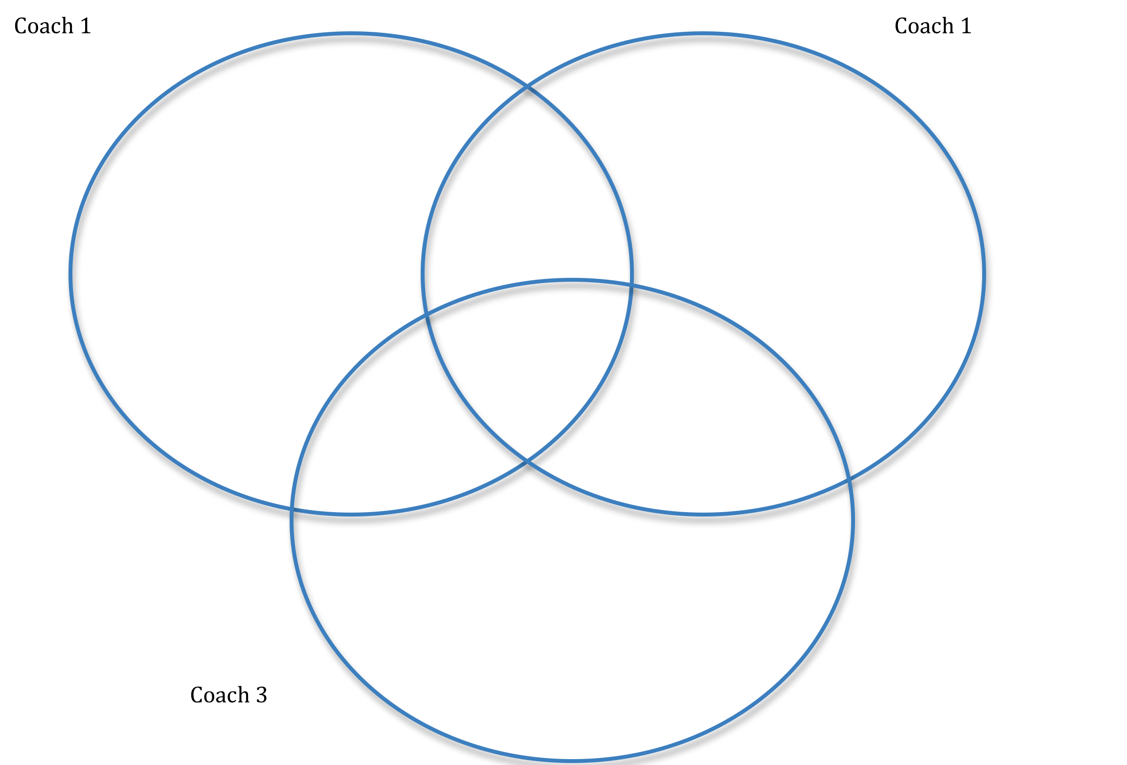

**Evaluation, review and refine:**

Writing down your coaching situation is an important first step. However, even the best plans fail. The following activity will help coaches’ state realistic visions and goals. Coaches should list on a continuum what would be **ideal** in terms of players, Program, staff and goals, and what would be **realistic.**

|  |  |
| --- | --- |
| **What is ideal for this team?** | **What is more likely real for this team?** |
|  |  |

**Training Elements and Priority Objectives:**

Team Unity

Psychological Factors

Team Play Factors

Technical/  
Tactical Factors

Physiological Factors

Factors Concerning the Athlete

Environmental Factors

**Team  
Vision**

**Action Plan Worksheet**

|  |  |  |
| --- | --- | --- |
| **Action Plan** | | |
| **Team: Date:** | | |
| **Mission:** | | |
| **Teams:** | | |
| **Tools:** | | |
| **Priority** | **Actions** | **Comment** |

**Evaluate, Review and Refine**

|  |  |  |
| --- | --- | --- |
| **Evaluation Plan** | | |
| **Team: Date:** | | |
| **Mission:** | | |
| **Processes** | **Evaluation Plans** | **Measures** |
| Vision, Values, Goals  The Influencing factors  The Objectives of each Action Plan  Our general and specific objectives  Our planning process |  |  |



